VI
I
I

DIGITAL IMAGE PROCESSING

L
ECTURE NOTES

B.E

(
I

YEAR
–

SEM)

(20
255
-
2
6
)

Prepared by:

Prof. Pooja Sarangpure

Department of Computer Science and Engineering

UNIT-1
DIGITAL IMAGE FUNDAMENTALS & IMAGE TRANSFORMS

DIGITAL IMAGE FUNDAMENTALS:
The field of digital image processing refers to processing digital images by means of digital computer. Digital image is composed of a finite number of elements, each of which has a particular location and value. These elements are called picture elements, image elements, pels and pixels. Pixel is the term used most widely to denote the elements of digital image.
An image is a two-dimensional function that represents a measure of some characteristic such as brightness or color of a viewed scene. An image is a projection of a 3D scene into a 2D projection plane.
An image may be defined as a two-dimensional function f(x,y), where x and y are spatial (plane) coordinates, and the amplitude of f at any pair of coordinates (x,y) is called the intensity of the image at that point.
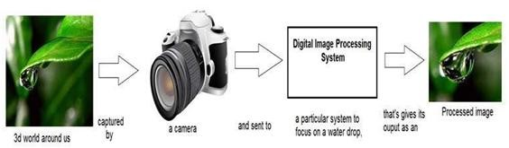
The term gray level is used often to refer to the intensity of monochrome images. Color images are formed by a combination of individual 2-D images.
For example: The RGB color system, a color image consists of three (red, green and blue) individual component images. For this reason many of the techniques developed for monochrome images can be extended to color images by processing the three component images individually.
An image may be continuous with respect to the x- and y- coordinates and also in amplitude. Converting such an image to digital form requires that the coordinates, as well as the amplitude, be digitized.

Components of Image processing System:
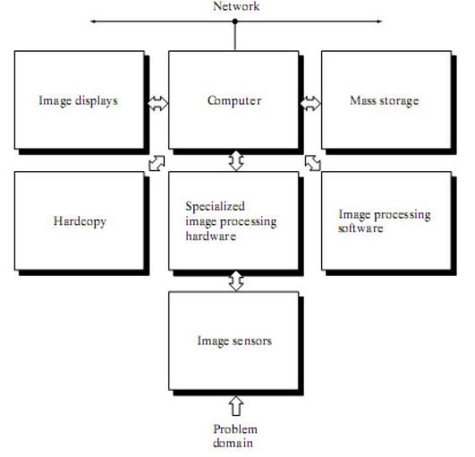

Figure : Components of Image processing System
Image Sensors: With reference to sensing, two elements are required to acquire digital image. The first is a physical device that is sensitive to the energy radiated by the object we wish to image and second is specialized image processing hardware.
Specialize image processing hardware: It consists of the digitizer just mentioned, plus hardware that performs other primitive operations such as an arithmetic logic unit, which performs arithmetic such addition and subtraction and logical operations in parallel on images.
Computer: It is a general purpose computer and can range from a PC to a supercomputer depending on the application. In dedicated applications, sometimes specially designed computer are used to achieve a required level of performance
Software: It consists of specialized modules that perform specific tasks a well designed package also includes capability for the user to write code, as a minimum, utilizes the specialized module. More sophisticated software packages allow the integration of these modules.
Mass storage: This capability is a must in image processing applications. An image of size 1024 x1024 pixels, in which the intensity of each pixel is an 8- bit quantity requires one Megabytes of storage space if the image is not compressed .Image processing applications falls into three principal categories of storage
i) Short term storage for use during processing ii) On line storage for relatively fast retrieval iii) Archival storage such as magnetic tapes and disks
Image display: Image displays in use today are mainly color TV monitors. These monitors are driven by the outputs of image and graphics displays cards that are an integral part of computer system.
Hardcopy devices: The devices for recording image includes laser printers, film cameras, heat sensitive devices inkjet units and digital units such as optical and CD ROM disk. Films provide the highest possible resolution, but paper is the obvious medium of choice for written applications.
Networking: It is almost a default function in any computer system in use today because of the large amount of data inherent in image processing applications. The key consideration in image transmission bandwidth.
Fundamental Steps in Digital Image Processing:
There are two categories of the steps involved in the image processing –
- Methods whose outputs are input are images.
- Methods whose outputs are attributes extracted from those images.
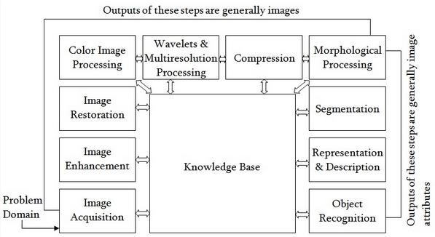

Fig: Fundamental Steps in Digital Image Processing
Image acquisition: It could be as simple as being given an image that is already in digital form. Generally the image acquisition stage involves processing such scaling.
Image Enhancement: It is among the simplest and most appealing areas of digital image processing. The idea behind this is to bring out details that are obscured or simply to highlight certain features of interest in image. Image enhancement is a very subjective area of image processing.
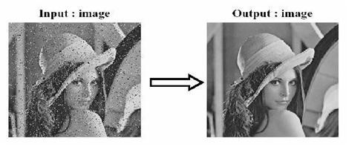
Image Restoration: It deals with improving the appearance of an image. It is an objective approach, in the sense that restoration techniques tend to be based on mathematical or probabilistic models of image processing. Enhancement, on the other hand is based on human subjective preferences regarding what constitutes a “good” enhancement result.
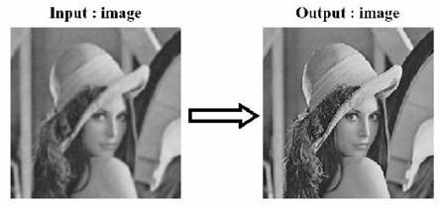
Color image processing: It is an area that is been gaining importance because of the use of digital images over the internet. Color image processing deals with basically color models and their implementation in image processing applications.
Wavelets and Multiresolution Processing: These are the foundation for representing image in various degrees of resolution.
Compression: It deals with techniques reducing the storage required to save an image, or the bandwidth required to transmit it over the network. It has to major approaches a) Lossless Compression b) Lossy Compression
Morphological processing: It deals with tools for extracting image components that are useful in the representation and description of shape and boundary of objects. It is majorly used in automated inspection applications.
Representation and Description: It always follows the output of segmentation step that is, raw pixel data, constituting either the boundary of an image or points in the region itself. In either case converting the data to a form suitable for computer processing is necessary. Recognition: It is the process that assigns label to an object based on its descriptors. It is the last step of image processing which use artificial intelligence of software.

Knowledge base:
Knowledge about a problem domain is coded into an image processing system in the form of a knowledge base. This knowledge may be as simple as detailing regions of an image where the information of the interest in known to be located. Thus limiting search that has to be conducted in seeking the information. The knowledge base also can be quite complex such interrelated list of all major possible defects in a materials inspection problems or an image database containing high resolution satellite images of a region in connection with change detection application.
A Simple Image Model:
An image is denoted by a two dimensional function of the form f{x, y}. The value or amplitude of f at spatial coordinates {x,y} is a positive scalar quantity whose physical meaning is determined by the source of the image. When an image is generated by a physical process, its values are proportional to energy radiated by a physical source. As a consequence, f(x,y) must be nonzero and finite; that is o<f(x,y) <co The function f(x,y) may be characterized by two components- The amount of the source illumination incident on the scene being viewed.
(a) The amount of the source illumination reflected back by the objects in the scene These are called illumination and reflectance components and are denoted by i(x,y) an r (x,y) respectively.
The functions combine as a product to form f(x,y). We call the intensity of a monochrome image at any coordinates (x,y) the gray level (l) of the image at that point l= f (x, y.)

L min ≤ l ≤ Lmax
Lmin is to be positive and Lmax must be finite
Lmin = imin rmin
Lmax = imax rmax
The interval [Lmin, Lmax] is called gray scale. Common practice is to shift this interval numerically to the interval [0, L-l] where l=0 is considered black and l= L-1 is considered white on the gray scale. All intermediate values are shades of gray of gray varying from black to white.
SAMPLING AND QUANTIZATION:
To create a digital image, we need to convert the continuous sensed data into digital from. This involves two processes – sampling and quantization. An image may be continuous with respect to the x and y coordinates and also in amplitude. To convert it into digital form we have to sample the function in both coordinates and in amplitudes.
Digitalizing the coordinate values is called sampling. Digitalizing the amplitude values is called quantization. There is a continuous the image along the line segment AB. To simple this function, we take equally spaced samples along line AB. The location of each samples is given by a vertical tick back (mark) in the bottom part. The samples are shown as block squares superimposed on function the set of these discrete locations gives the sampled function.
In order to form a digital, the gray level values must also be converted (quantized) into discrete quantities. So we divide the gray level scale into eight discrete levels ranging from eight level values. The continuous gray levels are quantized simply by assigning one of the eight discrete gray levels to each sample. The assignment it made depending on the vertical proximity of a simple to a vertical tick mark.
Starting at the top of the image and covering out this procedure line by line produces a two dimensional digital image.
Digital Image definition:
A digital image f(m,n) described in a 2D discrete space is derived from an analog image f(x,y) in a 2D continuous space through a sampling process that is frequently referred to as digitization. The mathematics of that sampling process will be described in subsequent Chapters. For now we will look at some basic definitions associated with the digital image. The effect of digitization is shown in figure.
The 2D continuous image f(x,y) is divided into N rows and M columns. The intersection of a row and a column is termed a pixel. The value assigned to the integer coordinates (m,n) with m=0,1,2..N-1 and n=0,1,2…N-1 is f(m,n). In fact, in most cases, is actually a function of many variables including depth, color and time (t).
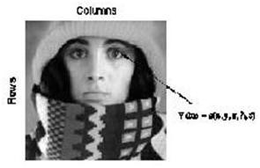
There are three types of computerized processes in the processing of image
- Low level process -these involve primitive operations such as image processing to reduce noise, contrast enhancement and image sharpening. These kind of processes are characterized by fact the both inputs and output are images.
- Mid level image processing - it involves tasks like segmentation, description of those objects to reduce them to a form suitable for computer processing, and classification of individual objects. The inputs to the process are generally images but outputs are attributes extracted from images.
- High level processing – It involves “making sense” of an ensemble of recognized objects, as in image analysis, and performing the cognitive functions normally associated with vision. Representing Digital Images:
The result of sampling and quantization is matrix of real numbers. Assume that an image f(x,y) is sampled so that the resulting digital image has M rows and N Columns. The values of the coordinates (x,y) now become discrete quantities thus the value of the coordinates at orgin become 9X,y) =(o,o) The next Coordinates value along the first signify the iamge along the first row. it does not mean that these are the actual values of physical coordinates when the image was sampled.
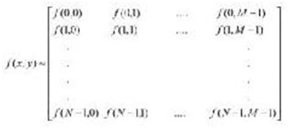
Thus the right side of the matrix represents a digital element, pixel or pel. The matrix can be represented in the following form as well. The sampling process may be viewed as partitioning the xy plane into a grid with the coordinates of the center of each grid being a pair of elements from the Cartesian products Z2 which is the set of all ordered pair of elements (Zi, Zj) with Zi and Zj being integers from Z. Hence f(x,y) is a digital image if gray level (that is, a real number from the set of real number R) to each distinct pair of coordinates (x,y). This functional assignment is the quantization process. If the gray levels are also integers, Z replaces R, the and a digital image become a 2D function whose coordinates and she amplitude value are integers. Due to processing storage and hardware consideration, the number gray levels typically is an integer power of 2.
k

L=2
Then, the number, b, of bites required to store a digital image is B=M *N* k When M=N, the
2 equation become b=N *k
When an image can have 2k gray levels, it is referred to as “k- bit”. An image with 256
8 possible gray levels is called an “8- bit image” (256=2 ).
Spatial and Gray level resolution:
Spatial resolution is the smallest discernible details are an image. Suppose a chart can be constructed with vertical lines of width w with the space between the also having width W, so a line pair consists of one such line and its adjacent space thus. The width of the line pair is 2w and there is 1/2w line pair per unit distance resolution is simply the smallest number of discernible line pair unit distance.
Gray levels resolution refers to smallest discernible change in gray levels. Measuring discernible change in gray levels is a highly subjective process reducing the number of bits R while repairing the spatial resolution constant creates the problem of false contouring.
It is caused by the use of an insufficient number of gray levels on the smooth areas of the digital image . It is called so because the rides resemble top graphics contours in a map. It is generally quite visible in image displayed using 16 or less uniformly spaced gray levels.
Image sensing and Acquisition:
The types of images in which we are interested are generated by the combination of an “illumination” source and the reflection or absorption of energy from that source by the elements of the “scene” being imaged. We enclose illumination and scene in quotes to emphasize the fact that they are considerably more general than the familiar situation in which a visible light source illuminates a common everyday 3-D (three-dimensional) scene. For example, the illumination may originate from a source of electromagnetic energy such as radar, infrared, or X-ray energy. But, as noted earlier, it could originate from less traditional sources, such as ultrasound or even a computer-generated illumination pattern. Similarly, the scene elements could be familiar objects, but they can just as easily be molecules, buried rock formations, or a human brain. We could even image a source, such as acquiring images

of the sun. Depending on the nature of the source, illumination energy is reflected from, or transmitted through, objects. An example in the first category is light reflected from a planar surface. An example in the second category is when X-rays pass through a patient‟s body for the purpose of generating a diagnostic X-ray film. In some applications, the reflected or transmitted energy is focused onto a photo converter (e.g., a phosphor screen), which converts the energy into visible light. Electron microscopy and some applications of gamma imaging use this approach. The idea is simple: Incoming energy is transformed into a voltage by the combination of input electrical power and sensor material that is responsive to the particular type of energy being detected. The output voltage waveform is the response of the sensor(s), and a digital quantity is obtained from each sensor by digitizing its response. In this section, we look at the principal modalities for image sensing and generation.
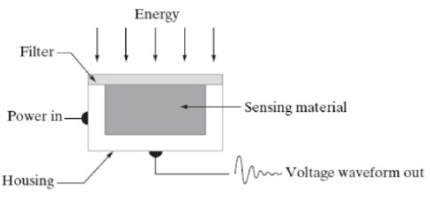

Fig:Single Image sensor

Fig: Line Sensor
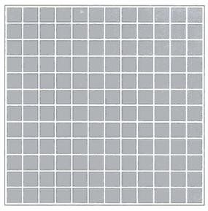
Fig: Array sensor Image Acquisition using a Single sensor:
The components of a single sensor. Perhaps the most familiar sensor of this type is the photodiode, which is constructed of silicon materials and whose output voltage waveform is proportional to light. The use of a filter in front of a sensor improves selectivity. For example, a green (pass) filter in front of a light sensor favors light in the green band of the color spectrum. As a consequence, the sensor output will be stronger for green light than for other components in the visible spectrum.
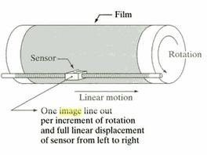
In order to generate a 2-D image using a single sensor, there has to be relative displacements in both the x- and y-directions between the sensor and the area to be imaged. Figure shows an arrangement used in high-precision scanning, where a film negative is mounted onto a drum whose mechanical rotation provides displacement in one dimension. The single sensor is mounted on a lead screw that provides motion in the perpendicular direction. Since mechanical motion can be controlled with high precision, this method is an inexpensive (but slow) way to obtain high-resolution images. Other similar mechanical arrangements use a flat bed, with the sensor moving in two linear directions. These types of mechanical digitizers sometimes are referred to as microdensitometers.
Image Acquisition using a Sensor strips:
A geometry that is used much more frequently than single sensors consists of an in-line arrangement of sensors in the form of a sensor strip, shows. The strip provides imaging elements in one direction. Motion perpendicular to the strip provides imaging in the other direction. This is the type of arrangement used in most flat bed scanners. Sensing devices with 4000 or more in-line sensors are possible. In-line sensors are used routinely in airborne imaging applications, in which the imaging system is mounted on an aircraft that flies at a constant altitude and speed over the geographical area to be imaged. One dimensional imaging sensor strips that respond to various bands of the electromagnetic spectrum are mounted perpendicular to the direction of flight. The imaging strip gives one line of an image at a time, and the motion of the strip completes the other dimension of a two-dimensional image. Lenses or other focusing schemes are used to project area to be scanned onto the sensors. Sensor strips mounted in a ring configuration are used in medical and industrial imaging to obtain cross-sectional (“slice”) images of 3-D objects.
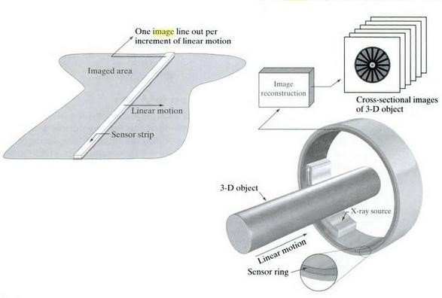
Fig: Image Acquisition using linear strip and circular strips.
Image Acquisition using a Sensor Arrays:
The individual sensors arranged in the form of a 2-D array. Numerous electromagnetic and some ultrasonic sensing devices frequently are arranged in an array format. This is also the predominant arrangement found in digital cameras. A typical sensor for these cameras is a CCD array, which can be manufactured with a broad range of sensing properties and can be packaged in rugged arrays of elements or more. CCD sensors are used widely in digital cameras and other light sensing instruments. The response of each sensor is proportional to the integral of the light energy projected onto the surface of the sensor, a property that is used in astronomical and other applications requiring low noise images. Noise reduction is achieved by letting the sensor integrate the input light signal over minutes or even hours. The two dimensional, its key advantage is that a complete image can be obtained by focusing the energy pattern onto the surface of the array. Motion obviously is not necessary, as is the case with the sensor arrangements This figure shows the energy from an illumination source being reflected from a scene element, but, as mentioned at the beginning of this section, the energy also could be transmitted through the scene elements. The first function performed by the imaging system is to collect the incoming energy and focus it onto an image plane. If the illumination is light, the front end of the imaging system is a lens, which projects the viewed scene onto the lens focal plane. The sensor array, which is coincident with the focal plane, produces outputs proportional to the integral of the light received at each sensor. Digital and analog circuitry sweep these outputs and convert them to a video signal, which is then digitized by another section of the imaging system.
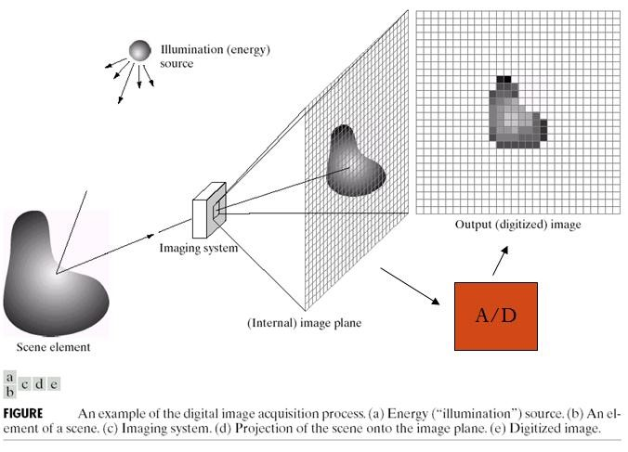
Image sampling and Quantization:
To create a digital image, we need to convert the continuous sensed data into digital form. This involves two processes: sampling and quantization. A continuous image, f(x, y), that we want to convert to digital form. An image may be continuous with respect to the x- and ycoordinates, and also in amplitude. To convert it to digital form, we have to sample the function in both coordinates and in amplitude. Digitizing the coordinate values is called sampling. Digitizing the amplitude values is called quantization.
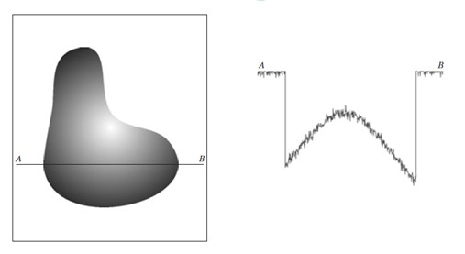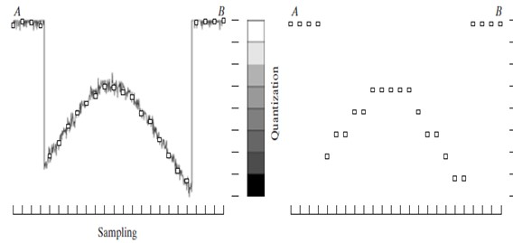

Digital Image representation:
Digital image is a finite collection of discrete samples (pixels) of any observable object. The pixels represent a two- or higher dimensional “view” of the object, each pixel having its own discrete value in a finite range. The pixel values may represent the amount of visible light, infra red light, absortation of x-rays, electrons, or any other measurable value such as ultrasound wave impulses. The image does not need to have any visual sense; it is sufficient that the samples form a two-dimensional spatial structure that may be illustrated as an image. The images may be obtained by a digital camera, scanner, electron microscope, ultrasound stethoscope, or any other optical or non-optical sensor. Examples of digital image are:
- digital photographs
- satellite images
- radiological images (x-rays, mammograms)
- binary images, fax images, engineering drawings
Computer graphics, CAD drawings, and vector graphics in general are not considered in this course even though their reproduction is a possible source of an image. In fact, one goal of intermediate level image processing may be to reconstruct a model (e.g. vector representation) for a given digital image.
RELATIONSHIP BETWEEN PIXELS:
We consider several important relationships between pixels in a digital image.
NEIGHBORS OF A PIXEL
• A pixel p at coordinates (x,y) has four horizontal and vertical neighbors whose coordinates are given by:

(x+1,y), (x-1, y), (x, y+1), (x,y-1)
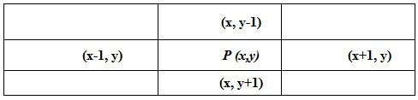
This set of pixels, called the 4-neighbors or p, is denoted by N₄(p). Each pixel is one unit distance from (x,y) and some of the neighbors of p lie outside the digital image if (x,y) is on the border of the image. The four diagonal neighbors of p have coordinates and are denoted by N_{D} (p).

(x+1, y+1), (x+1, y-1), (x-1, y+1), (x-1, y-1)
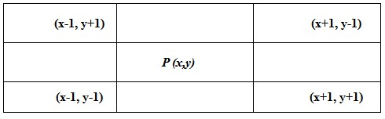
These points, together with the 4-neighbors, are called the 8-neighbors of p, denoted by N₈ (p).
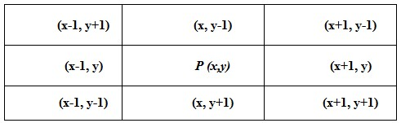
As before, some of the points in N_{D} (p) and N₈ (p) fall outside the image if (x,y) is on the border of the image.
ADJACENCY AND CONNECTIVITY
Let v be the set of gray –level values used to define adjacency, in a binary image, v={1}. In a gray-scale image, the idea is the same, but V typically contains more elements, for example, V = {180, 181, 182, …, 200}.
If the possible intensity values 0 – 255, V set can be any subset of these 256 values. if we are reference to adjacency of pixel with value. Three types of adjacency
- 4- Adjacency – two pixel P and Q with value from V are 4 –adjacency if A is in the set N₄(P)
- 8- Adjacency – two pixel P and Q with value from V are 8 –adjacency if A is in the set N₈(P)
- M-adjacency –two pixel P and Q with value from V are m – adjacency if (i) Q is in N₄(p) or (ii) Q is in N_{D}(q) and the set N₄(p) ∩ N₄(q) has no pixel whose values are from V.
- Mixed adjacency is a modification of 8-adjacency. It is introduced to eliminate the ambiguities that often arise when 8-adjacency is used.
- For example:
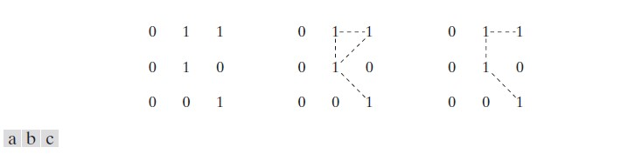

Fig:1.8(a) Arrangement of pixels; (b) pixels that are 8-adjacent (shown dashed) to the center pixel; (c) m-adjacency.
Types of Adjacency:
- In this example, we can note that to connect between two pixels (finding a path between two pixels):

– In 8-adjacency way, you can find multiple paths between two pixels
– While, in m-adjacency, you can find only one path between two pixels
- So, m-adjacency has eliminated the multiple path connection that has been generated by the 8-adjacency.
- Two subsets S₁ and S₂ are adjacent, if some pixel in S₁ is adjacent to some pixel in S₂.
Adjacent means, either 4-, 8- or m-adjacency.
A Digital Path:
- A digital path (or curve) from pixel p with coordinate (x,y) to pixel q with coordinate (s,t) is a sequence of distinct pixels with coordinates (x₀,y₀), (x₁,y₁), …, (x_{n}, y_{n}) where (x₀,y₀) =
(x,y) and (x_{n}, y_{n}) = (s,t) and pixels (x_{i}, y_{i}) and (x_{i-1}, y_{i-1}) are adjacent for 1 ≤ i ≤ n
- n is the length of the path
- If (x₀,y₀) = (x_{n}, y_{n}), the path is closed.
We can specify 4-, 8- or m-paths depending on the type of adjacency specified.
- Return to the previous example:
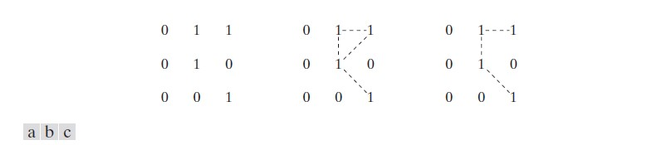
Fig:1.8 (a) Arrangement of pixels; (b) pixels that are 8-adjacent(shown dashed) to the center pixel; (c) m-adjacency.
In figure (b) the paths between the top right and bottom right pixels are 8-paths. And the path between the same 2 pixels in figure (c) is m-path Connectivity:
- Let S represent a subset of pixels in an image, two pixels p and q are said to be connected in S if there exists a path between them consisting entirely of pixels in S.
- For any pixel p in S, the set of pixels that are connected to it in S is called a connected component of S. If it only has one connected component, then set S is called a connected set.
Region and Boundary:
- REGION: Let R be a subset of pixels in an image, we call R a region of the image if R is a connected set.
- BOUNDARY: The boundary (also called border or contour) of a region R is the set of pixels in the region that have one or more neighbors that are not in R. If R happens to be an entire image, then its boundary is defined as the set of pixels in the first and last rows and columns in the image. This extra definition is required because an image has no neighbors beyond its borders. Normally, when we refer to a region, we are referring to subset of an image, and any pixels in the boundary of the region that happen to coincide with the border of the image are included implicitly as part of the region boundary.
DISTANCE MEASURES:
For pixel p,q and z with coordinate (x.y) ,(s,t) and (v,w) respectively D is a distance function or metric if
D [p.q] ≥ O {D[p.q] = O iff p=q}
D [p.q] = D [p.q] and
D [p.q] ≥ O {D[p.q]+D(q,z)
- The Euclidean Distance between p and q is defined as:

D_{e} (p,q) = [(x – s)² + (y - t)²]^{1/2}

Pixels having a distance less than or equal to some value r from (x,y) are the points contained in a disk of radius „ r „centered at (x,y)
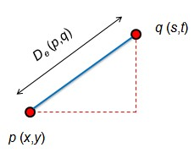
- The D₄ distance (also called city-block distance) between p and q is defined as:
D₄ (p,q) = | x – s | + | y – t |
Pixels having a D₄ distance from (x,y), less than or equal to some value r form a Diamond centered at (x,y)
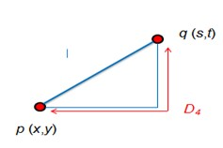
Example:
The pixels with distance D₄ ≤ 2 from (x,y) form the following contours of constant distance.
The pixels with D₄ = 1 are the 4-neighbors of (x,y)

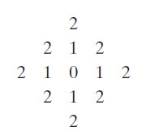
- The D₈ distance (also called chessboard distance) between p and q is defined as:
D₈ (p,q) = max(| x – s |,| y – t |)
Pixels having a D₈ distance from (x,y), less than or equal to some value r form a square Centered at (x,y).
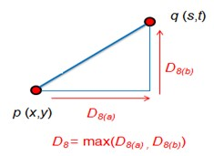
Example:
D₈ distance ≤ 2 from (x,y) form the following contours of constant distance.
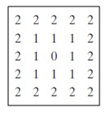
- D_{m} distance:
It is defined as the shortest m-path between the points.
In this case, the distance between two pixels will depend on the values of the pixels along the path, as well as the values of their neighbors.
- Example:
Consider the following arrangement of pixels and assume that p, p₂, and p₄ have value 1 and that p₁ and p₃ can have can have a value of 0 or 1 Suppose that we consider the adjacency of pixels values 1 (i.e. V = {1})
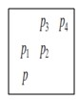
Now, to compute the D_{m} between points p and p₄ Here we have 4 cases:
Case1: If p₁ =0 and p₃ = 0
The length of the shortest m-path
(the D_{m} distance) is 2 (p, p₂, p₄)
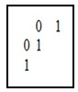
Case2: If p₁ =1 and p₃ = 0 now, p₁ and p will no longer be adjacent (see m-adjacency definition) then, the length of the shortest path will be 3 (p, p₁, p₂, p₄)
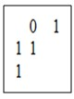
Case3: If p₁ =0 and p₃ = 1
The same applies here, and the shortest –m-path will be 3 (p, p₂, p₃, p₄)
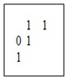
Case4: If p₁ =1 and p₃ = 1
The length of the shortest m-path will be 4 (p, p₁ , p₂, p₃, p₄)
